|  |  |  |  |  |
| --- | --- | --- | --- | --- |
| |  |  | | --- | --- | | League  Info Server | Image result for football league cup | | Image result for football kick | Image result for football batches | |
| Documentation  Covers Architecture, API Specification using Swagger, Cross Browser & Device UI Testing, UI Unit Testing, UI Automated Testing, Security Testing, Service Unit & Integration Testing, API Performance Testing, Jenkins Pipeline setup, Tech stack used, Deployment structure, Code structure |

Table of Contents

Accessing the Service 3

Accessing the API from Swagger 4

Architecture 5

Technology Stack 6

Cross Browser / Device Testing 7

Setting up & Running the solution locally 8

Pre-requisites 8

Setup Steps 8

Jenkins Pipeline Setup 9

UI Unit Tests – Jest, Enzyme 10

UI Automated Testing - Selenium 11

Security Testing – ZA Proxy 12

Service Unit Testing – JUnit & Mockito 13

Service Integration Testing - RESTAssured 14

API Performance Testing - JMeter 15

Jenkins – Single click deployment to PROD 16

Code Package Structure 17

Service Code Package Structure 18

Deployment Structure 19

# Accessing the Service

You can access the service from this URL: <http://13.58.209.5:8080>



# Accessing the API from Swagger

You can also access the core API via swagger using this URL: <http://13.58.209.5:8080/v1/swagger-ui.html>

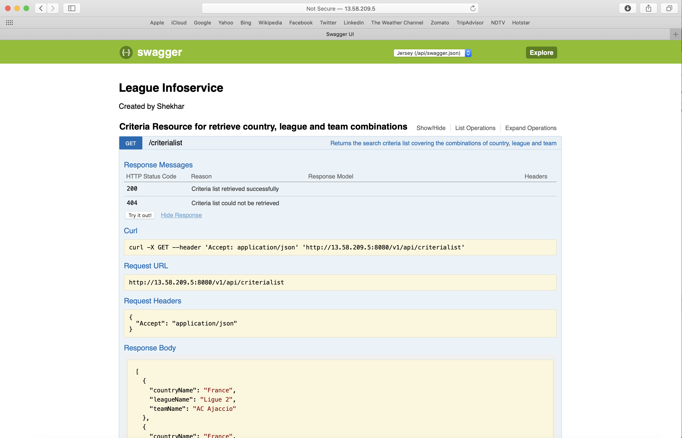

# Architecture

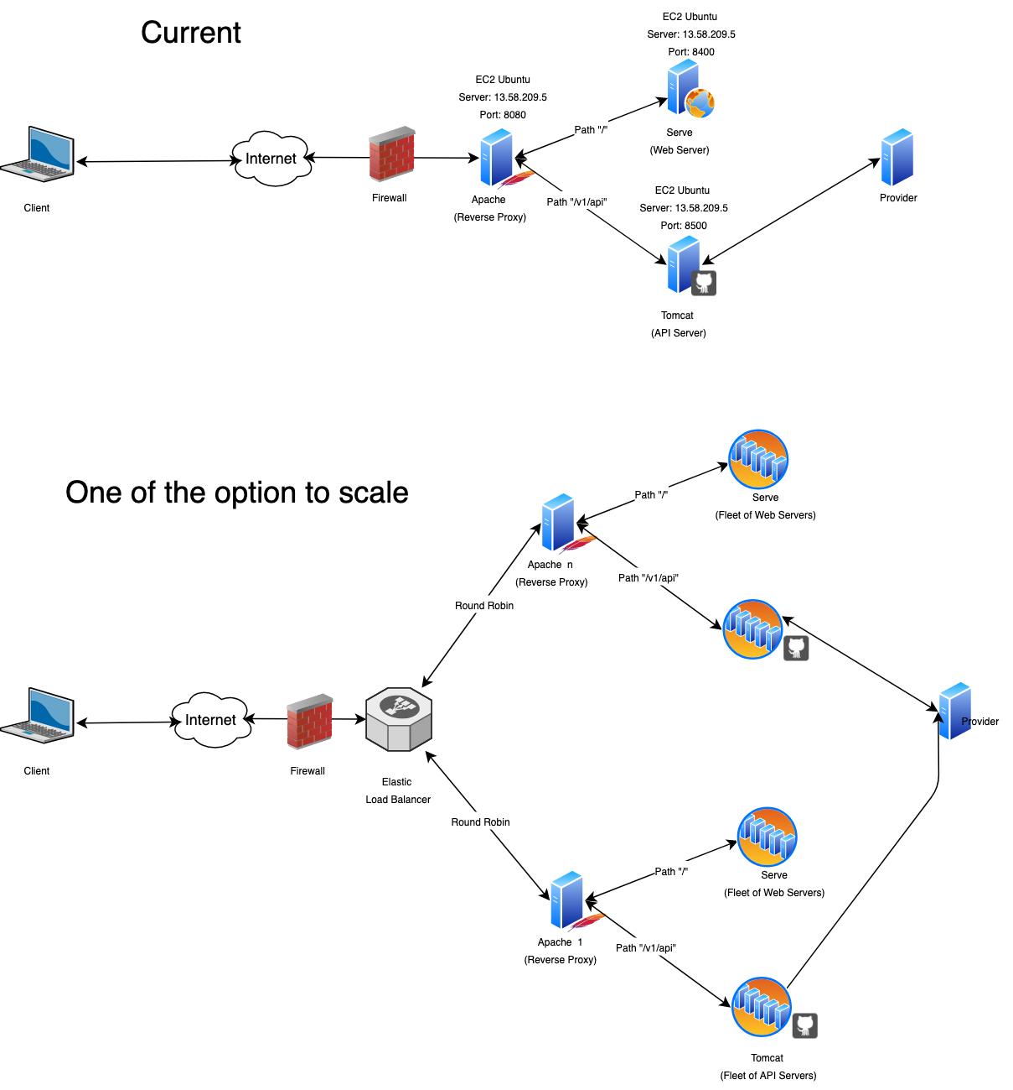Note: Other options can be discussed based on Use Cases / NFR / Budget / Different or extended Technology Stacks / Cloud services

# Technology Stack

|  |  |  |
| --- | --- | --- |
| Image result for java image | Image result for spring boot image | /var/folders/q9/x9xlkwy90xd9jlz6l1fg4pbwx7n7pf/T/com.microsoft.Word/WebArchiveCopyPasteTempFiles/logo-transparent.pngRestAssured |
| Image result for Maven image | Image result for tomcat image | Image result for Junit image |
| Image result for Mockito | Image result for JMeter image | Image result for selenium |
| Image result for Node.js | Image result for reactjs logo | Image result for Jenkins logo |
| Image result for zaproxy logo  ZA Proxy | Image result for xcode logo  XCode | Image result for aws logo |
| Image result for ubuntu logo | Image result for apple mac logo | Image result for windows 10 logo |

# Cross Browser / Device Testing

Tested the solution in the following browsers & Devices (some of them are listed below): Chrome, Safari, Firefox, Edge, IPhone, IPad, Android

|  |  |
| --- | --- |
| **Safari** | **Chrome** |
|  |  |
| **Firefox** | **IPad Air** |
|  |  |
| **IPhone 6** | **IPhone XR** |
|  |  |

# Setting up & Running the solution locally

## Pre-requisites

* Install Java 8
* Install node.js (v10.16.1) and npm (v6.9.0)
* Install serve globally (npm install -g serve)
* Install JMeter (Optional)

## Setup Steps

1. Check out the code from github (git clone <https://github.com/siyer70/leagueinfoserver>)
   * Once checked-out, Change directory to this folder
   * Note: All under-mentioned commands are to be executed from this root directory of the checked-out folder only
2. Build the code with the under-mentioned command
   * Command: “**jenkins/scripts/build.sh DEV 1.0**” (use “**jenkins/scripts/build.sh PROD 1.0”** for PROD**)**
   * Use Gitbash for Windows to run the above
3. Start the services: **bin/start.sh (MAC / Linux) or bin\start.bat (Windows)**
   * You can stop the services by using: **bin/stop.sh (MAC / Linux)** - In Windows – simply close the spawned windows
4. Check the status of the service: **bin/status.sh (MAC / Linux)** - In Windows, status is visible in the spawned windows
   * Status should be running
   * UI code runs in **3000** port of localhost (npm start default) – In Prod, port **8400** is used in EC2 host
   * Service runs in **8500** port of localhost – In Prod, same port is used in EC2 host
   * So, you can access the app using url:
     + Local: <http://localhost:3000/>
     + Prod: <http://13.58.209.5:8080>
       - In Prod, since 8080 is the only port opened, Apache as reverse proxy / gateway is configured in this port to manage the requests for both Web Server & API Server (see the architecture page for more details)
   * And access the API service using the swagger url:
     + Local: <http://localhost:8500/v1/swagger-ui.html>
     + Prod: <http://13.58.209.5:8080/v1/swagger-ui.html>

# Jenkins Pipeline Setup

Jenkins pipeline has been setup for build, test and deploy

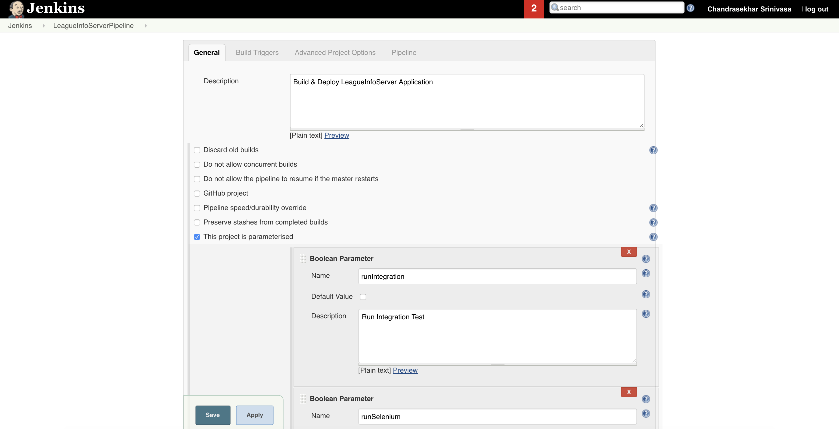

# UI Unit Tests – Jest, Enzyme

UI Unit tests along with coverage:

Tech stack Used: Jest, Enzyme, Fetch-reply-with

Alternatives: Mocha, Chai, Enzyme, Fake-Fetch

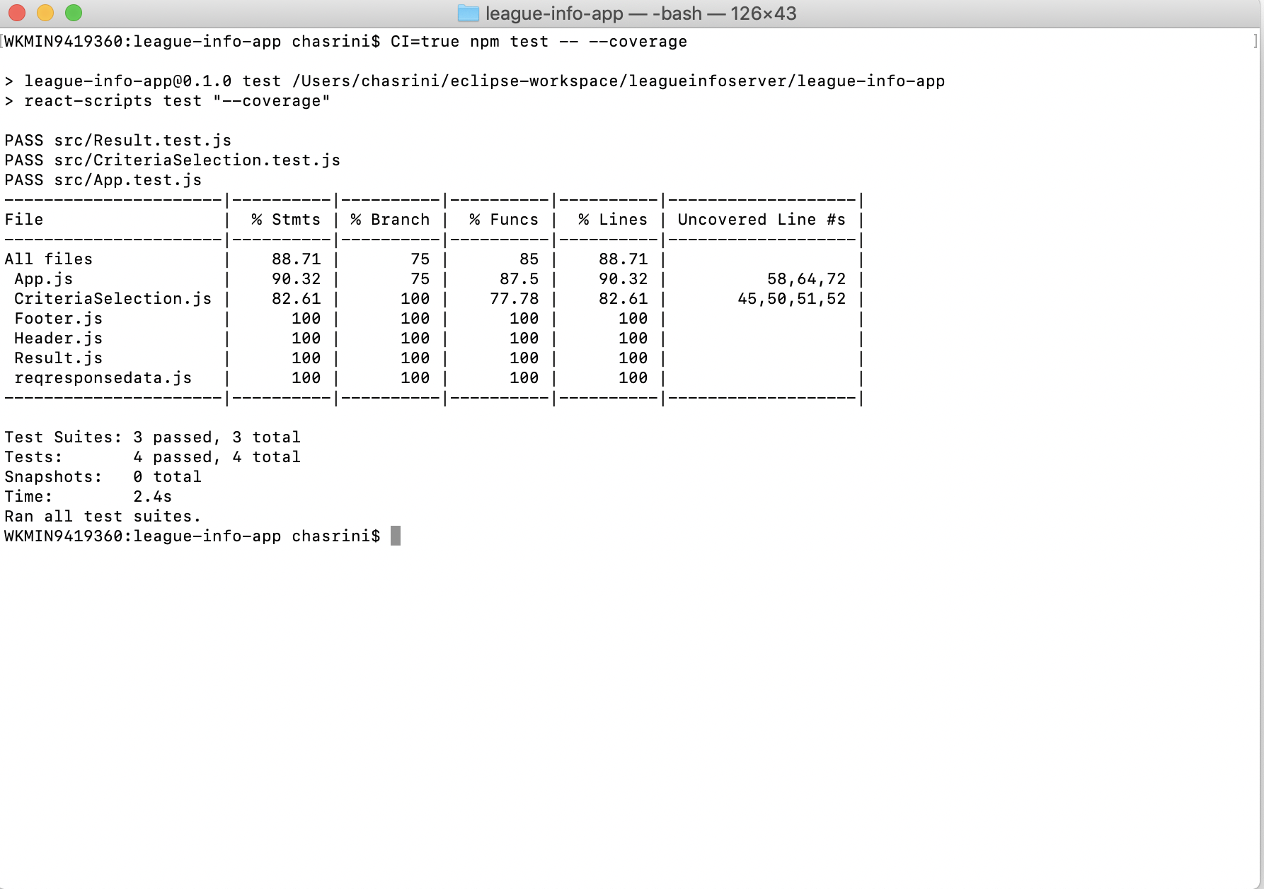

# UI Automated Testing - Selenium

You can execute the UI Automation testing from Jenkins Pipeline or using Maven Command or from Eclipse – to keep it simple, Jenkins UI has been shown below from where you can execute this test.

Tech stack Used: Selenium Java (Server Mode)

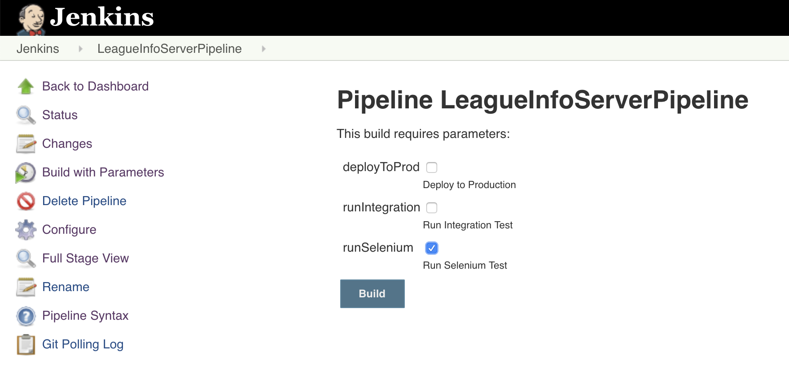

# Security Testing – ZA Proxy

Tech stack Used: ZA Proxy

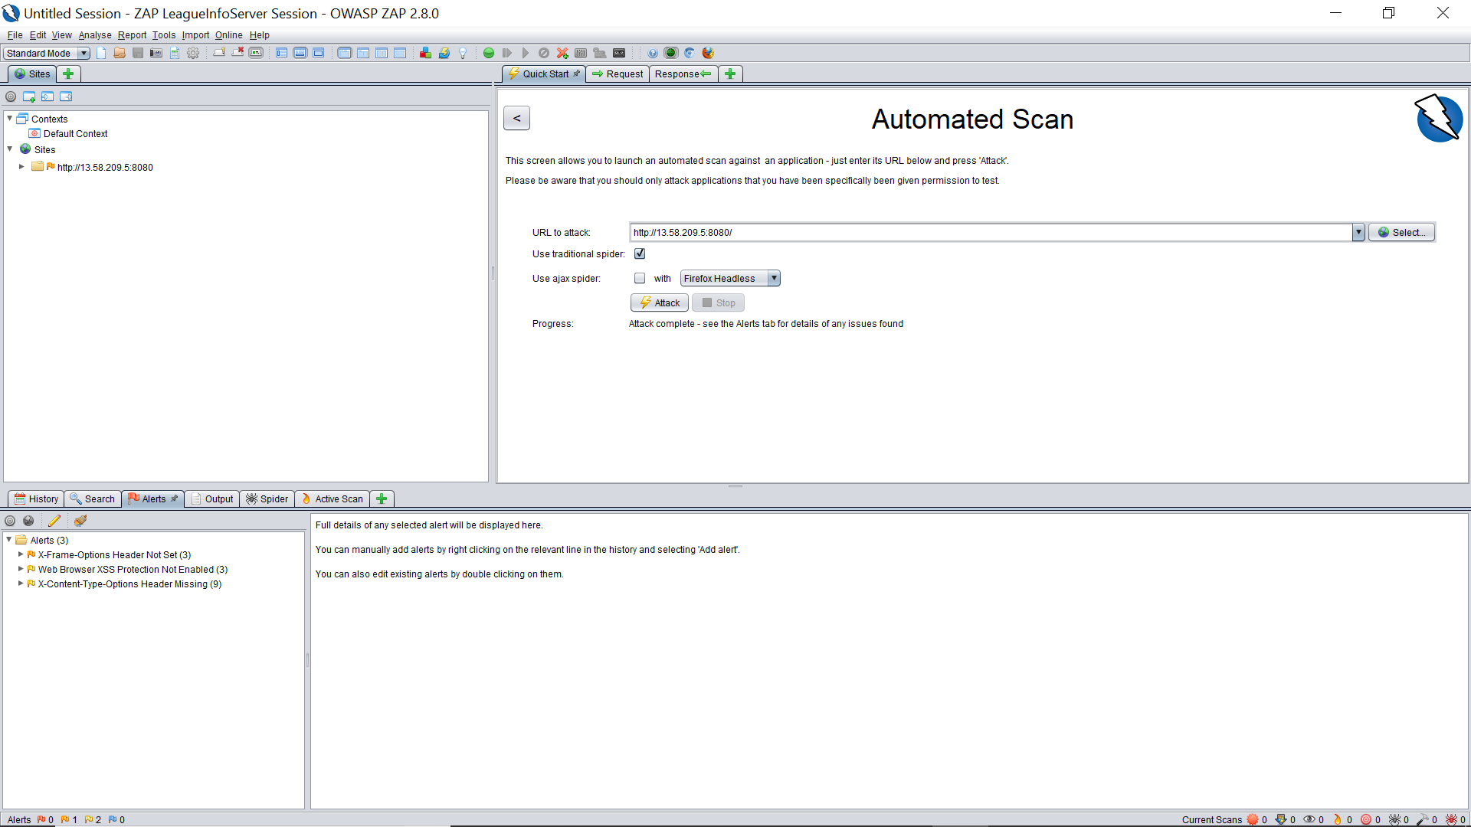

# Service Unit Testing – JUnit & Mockito

For running the unit testing for the Service – simply run the Jenkins build without checking any parameters

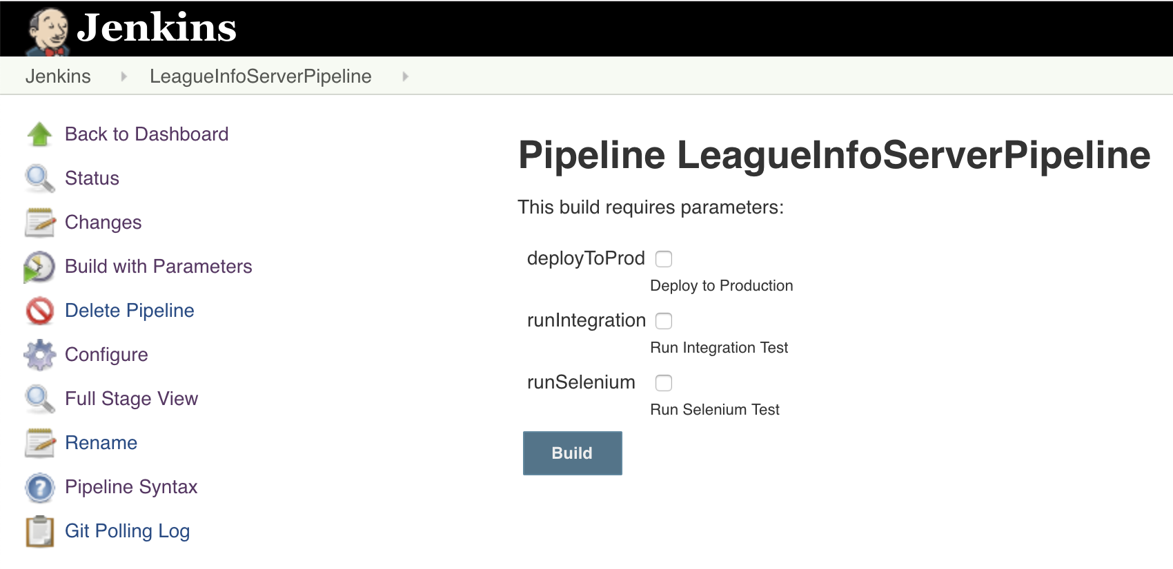

# Service Integration Testing - RESTAssured

For running the integration testing for the Service – simply check the integration test check box in the build

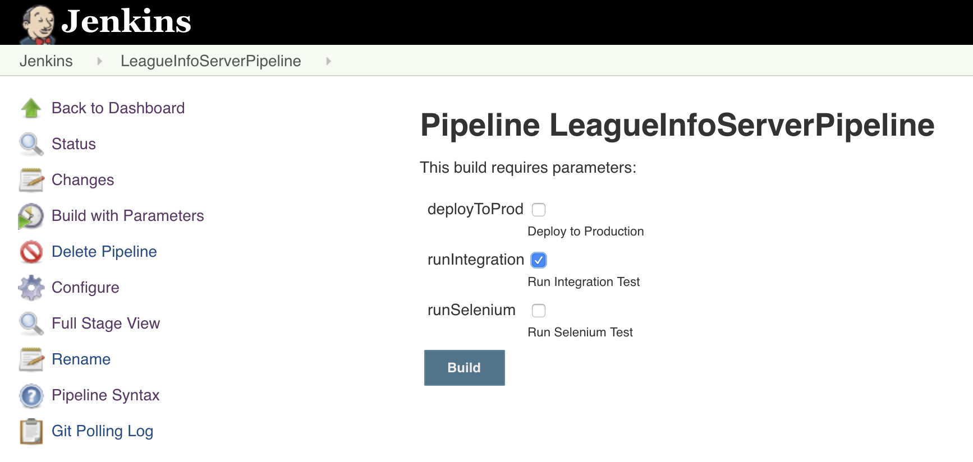

# API Performance Testing - JMeter

You can run the performance test by simply running the script file from the bin folder i.e. **bin/run-jmeter-api-test.sh**

Pre-requisite:

1. Install latest version of JMeter
2. Run the Services: bin/start.sh

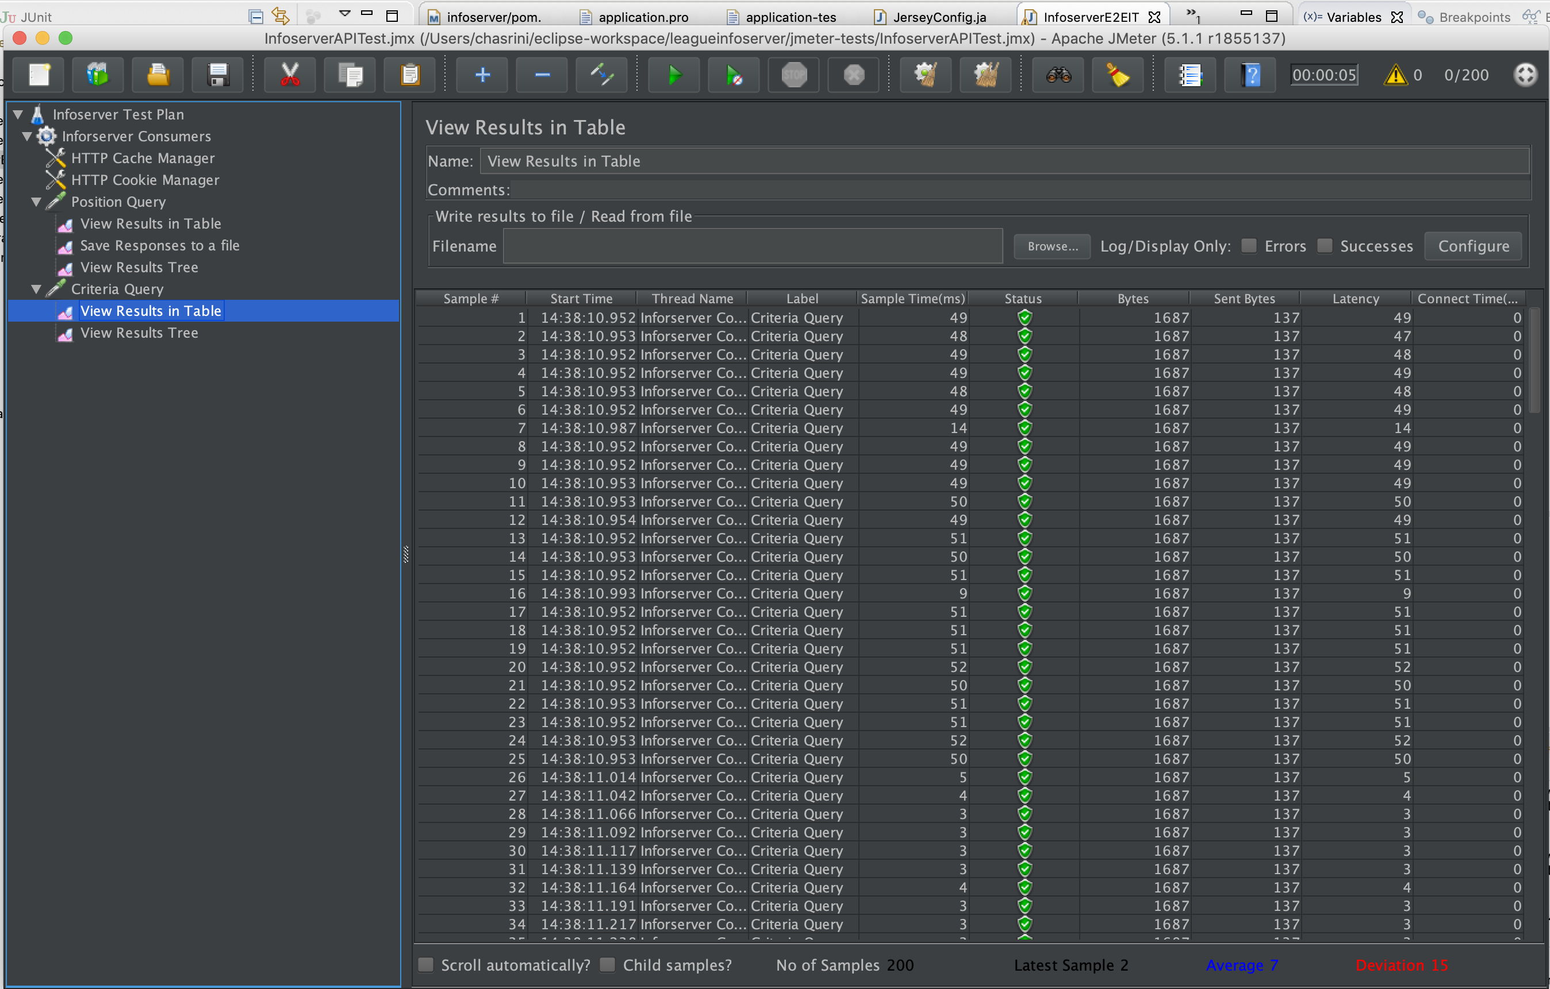

# Jenkins – Single click deployment to PROD

For deploying to PROD, simply click on the deploy to prod option in Jenkins

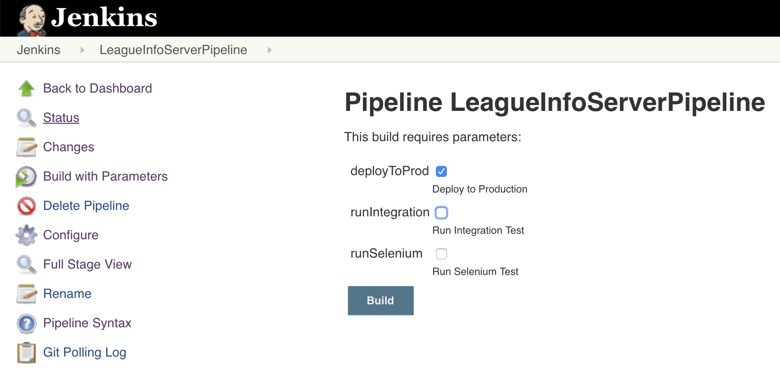

# Code Package Structure

drwxr-xr-x 3 chasrini LL\Domain Users 96 Aug 17 08:47 apache

drwxr-xr-x 8 chasrini LL\Domain Users 256 Sep 2 20:53 bin

drwxr-xr-x 3 chasrini LL\Domain Users 96 Sep 1 13:37 jenkins

drwxr-xr-x 13 chasrini LL\Domain Users 416 Sep 2 17:32 infoserver

drwxr-xr-x 18 chasrini LL\Domain Users 576 Sep 1 13:44 league-info-app

drwxr-xr-x 5 chasrini LL\Domain Users 160 Sep 1 13:37 jmeter-tests

drwxr-xr-x 4 chasrini LL\Domain Users 128 Sep 2 21:58 doc

-rw-r--r-- 1 chasrini LL\Domain Users 888 Sep 2 09:36 README.md

drwxr-xr-x 4 chasrini LL\Domain Users 128 Sep 2 17:32 releases

drwxr-xr-x 4 chasrini LL\Domain Users 128 Sep 1 13:27 logs

|  |  |
| --- | --- |
| Directory | Description |
| Apache | Apache configuration for production – not required for local testing |
| Bin | Start, stop and status scripts and script to run jmeter |
| Jenkins | All the jenkin scripts are available here within the scripts folder |
| Infoserver | API service Java code |
| League-info-app | UI code - react components |
| Jmeter-tests | Jmeter jmx file |
| Doc | This document is available within this folder |
| README.md | Read me file |
| Releases | All release artifacts will be available here |
| Logs | Log files will be available here |

# Service Code Package Structure

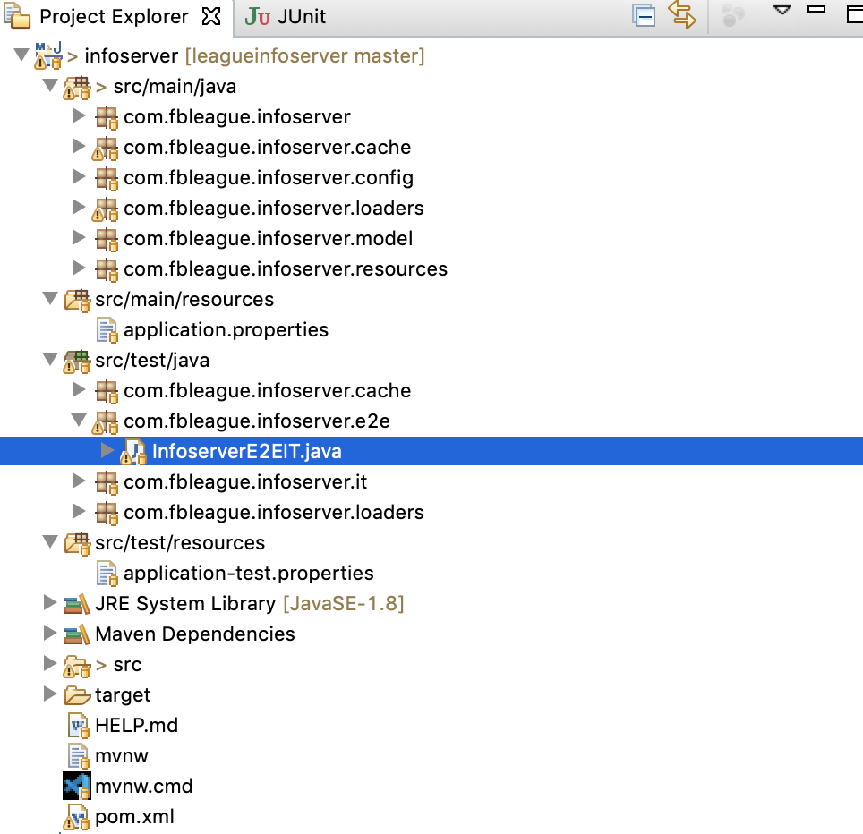

# Deployment Structure

**ubuntu@ip-172-31-30-142**:**~/infoserver**$ ls -ltr

total 48856

drwxrwxr-x 2 ubuntu ubuntu 4096 Aug 18 22:01 **logs**

drwxrwxr-x 3 ubuntu ubuntu 4096 Aug 25 18:36 **releases**

drwxrwxr-x 2 ubuntu ubuntu 4096 Sep 1 21:51 **bin**

drwxrwxr-x 2 ubuntu ubuntu 4096 Sep 2 17:45 **backup**

**ubuntu@ip-172-31-30-142**:**~/infoserver**$ ls -ltr releases/PROD/infoserver-1.0/

total 54148

-rw-r--r-- 1 ubuntu ubuntu 55440883 Aug 25 12:57 **infoserver-1.0.jar**

drwxr-xr-x 3 ubuntu ubuntu 4096 Aug 25 12:57 **build**

|  |  |
| --- | --- |
| Directory | Description |
| /etc/apache2 | Apache configuration for production |
| Bin | Start, stop and status scripts and script to run jmeter |
| Releases | All releases are extracted in this folder |
| Backup | Release artifacts (tar files) backup for the past releases |
| Logs | Log files will be available here |